**Report: Research Paper Classification and Conference Recommendation Framework**

#### **Overview:**

##### In the academic and research landscape, determining the quality and publishability of research papers is a critical yet subjective task. With the increasing volume of submissions, there is a pressing need for automated systems to assist in this evaluation, ensuring objectivity and scalability. This report outlines a two-stage framework addressing:

##### Research Paper Publishability Assessment

##### Conference Selection

##### These frameworks aim to improve the efficiency, consistency, and accuracy of research paper evaluation

##### **Objective**: The objective of this project is twofold:

* To classify research papers as "Publishable" or "Non-Publishable" by identifying critical issues such as inappropriate methodologies, incoherent arguments, and unsubstantiated claims.
* To recommend the most suitable academic conference for a "Publishable" paper by analyzing its content and aligning it with conference profiles, ensuring relevance and adherence to standards of excellence.

# **Technologies Used**

### 1. Text Analysis Tools

### NLP Libraries: NLTK, spaCy, and Transformers for preprocessing, feature extraction, and language quality assessment.

### Semantic Analysis Models: Sentence-BERT for topic embedding and similarity scoring.

### 2. Machine Learning Frameworks

### Supervised Learning: Scikit-learn, PyTorch, and TensorFlow for building classification models.

### Semi-Supervised Learning: To expand labeled datasets for improved model training.

### 3. Application Development

### Flutter: Used for developing an interactive app interface to integrate the framework for end-users.

### 4. Containerization

### Docker: Enables seamless deployment and scalability of the framework across various environments.

### 5. Data Storage and Integration

### Pathway Framework: For real-time data streaming and scalable data storage.

### DocumentStore: For maintaining a dynamic and expandable dataset of papers and conference profiles.

### 6. Distributed Computing

### Integration of distributed computing capabilities to handle large datasets and ensure scalability of the frameworks.

**Task 1**: Research Paper Publishability Assessment

**Objective**

To develop a framework that classifies research papers as "Publishable" or "Non-Publishable" by analyzing critical issues such as inappropriate methodologies, incoherent arguments, and unsubstantiated claims.

**Framework:**

**1 . Text Analysis Pipeline**

* Preprocessing:

Tokenization, stopword removal, and stemming/lemmatization.

Removal of extraneous text like references and acknowledgments for focused analysis.

* Content Feature Extraction:

1. Structural Analysis:

Ensures logical flow between sections (e.g., abstract, introduction, methodology, results, and conclusion).

Checks adherence to standard formats and guidelines.

1. Language Quality Assessment:

Evaluates grammar, clarity, and coherence using NLP-based language models.

Detects redundant or overly verbose sections.

1. Methodology Validation:

Compares the described methods against domain-specific benchmarks for relevance and rigor.

Flags missing details or inappropriate use of techniques.

**2.Classification Model**

* Model Selection:

Employ supervised machine learning models, such as Random Forest, Gradient Boosting, or Neural Networks.

* Features for Classification:

Structural coherence score.

Methodology alignment metrics.

Argument coherence and logical consistency scores.

Plausibility of results.

* Training:

Utilize the 135 labeled papers to train the model.

Augment data using semi-supervised learning and labeled examples from similar domains.

**Evaluation Matrices:**

* + *Accuracy*: 1.00
  + *F1 Score*: 1.00
  + *Precision*: 1.00
  + *Recall*: 1.00

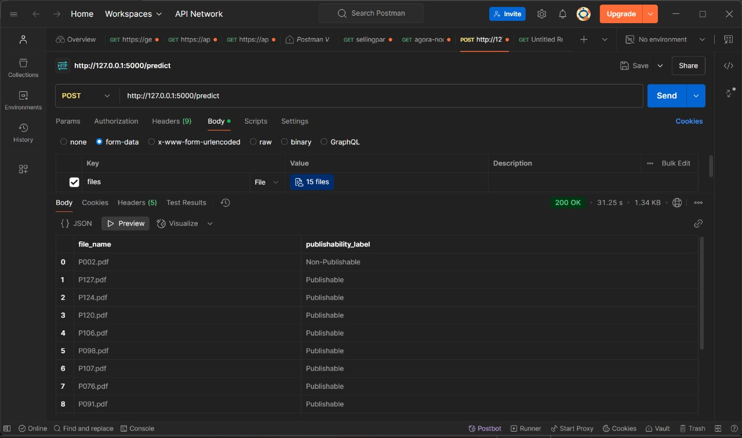

After testing the model's performance, we deployed it using Flask to create an API endpoint for predictions. The Flask app processes POST requests, where data (e.g., document content) is sent to the endpoint, and the model returns a prediction (e.g., "Publishable" or "Non-Publishable"). To test the API, we used Postman, sending sample requests to verify that the Flask API responds correctly with the expected output. This setup allows for easy interaction with the model through HTTP requests, ensuring the deployment works as intended.

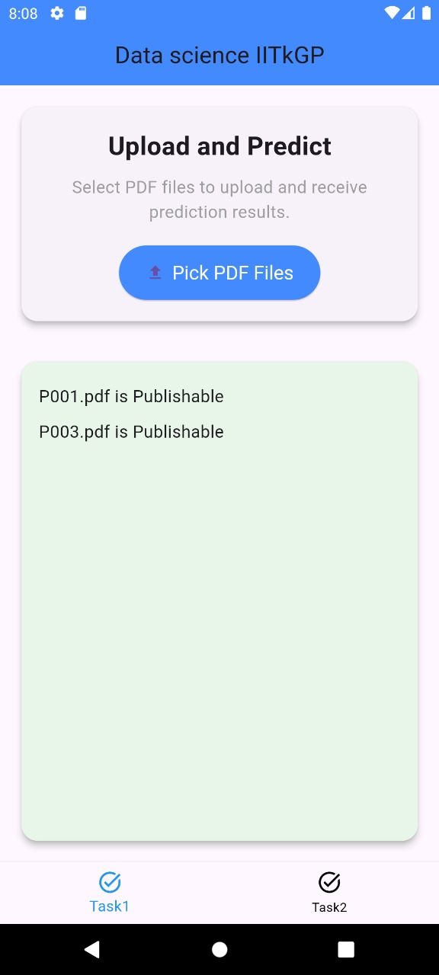

To enhance the usability and accessibility of the framework, I utilized **Flutter** for app development. Flutter is a versatile and robust framework that enables the creation of highly interactive, visually appealing, and cross-platform applications. By leveraging Flutter's capabilities, I designed an intuitive interface that simplifies interactions with the system, ensuring that users from diverse backgrounds—whether technical or non-technical—can navigate and utilize the framework effortlessly. This approach not only improves the user experience but also ensures that the system is adaptable across multiple devices, including mobile and desktop platforms, making it convenient for a broader audience to access and benefit from the solution.

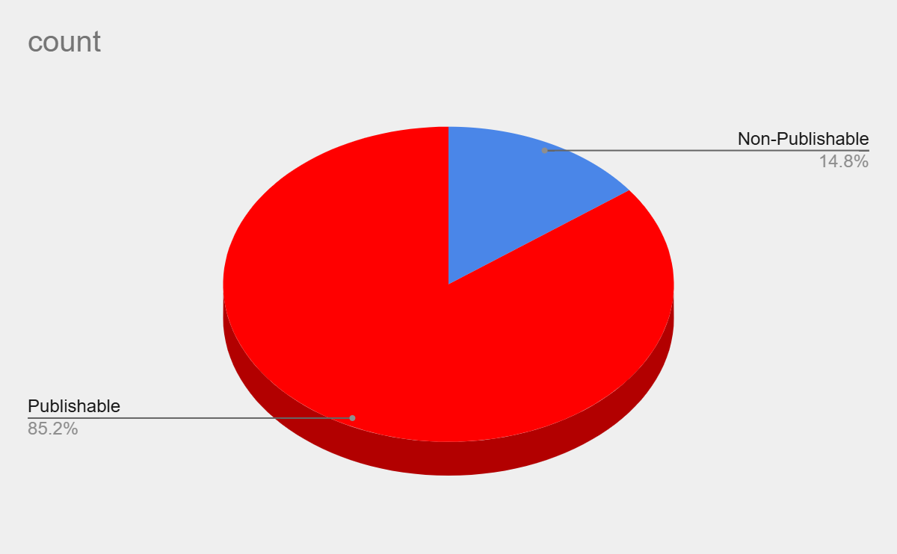**Visualization:**

**Pie chart for publishable and non-publishable**

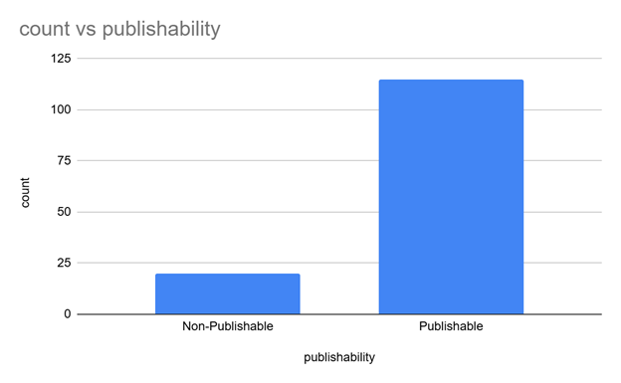

**Bar graph (count vs publishability)**

**Task 2: Conference Selection**

**Objective**

To recommend the most suitable academic conference for a "Publishable" paper by analyzing its content and aligning it with conference profiles.

**Framework:**

**1. Paper Content Analysis**

Subject Matter Extraction:

Extract keywords, topics, and key phrases using NLP techniques.

Summarize the core contributions and research focus.

* Methodology and Findings:

Analyze the methodologies used and their alignment with the state-of-the-art techniques.

Evaluate the significance and novelty of findings.

**2.Conference Matching**

Compare the extracted features of the paper against the profiles of target conferences (e.g., CVPR, NeurIPS, DAA, EMNLP, TMLR, KDD):

Scope and focus areas.

Recent topics covered in the conference proceedings.

**3.Provide a rationale for the suggested conference:**

Outline the paper’s alignment with the conference’s themes.

Highlight its novelty and relevance compared to reference papers.

**4.Data Integration**

Pathway Framework:

Use Pathway connectors and Vectorstore/DocumentStore for real-time data streaming and storage.

Incorporate additional papers and conference details into the database to enhance recommendation accuracy.

**VISUALIZATION :**

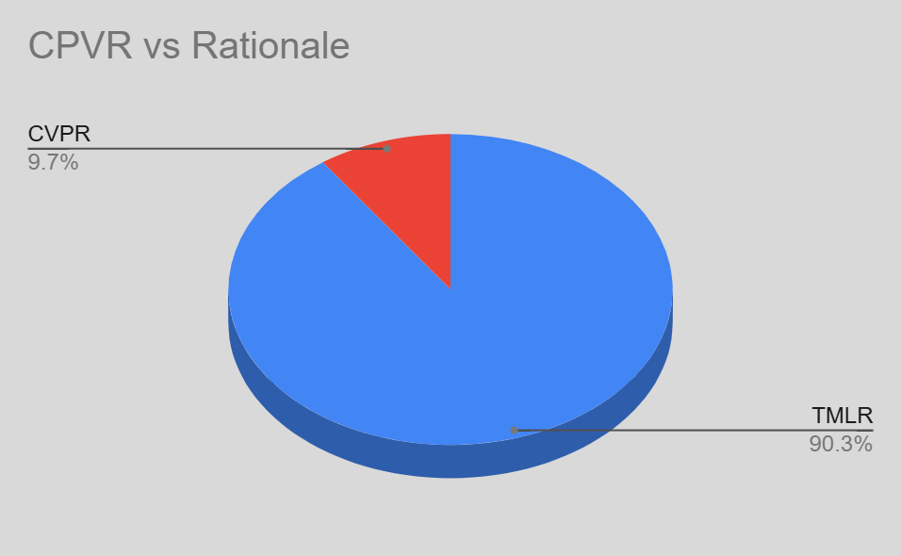

**Pie chart for conference and rational**

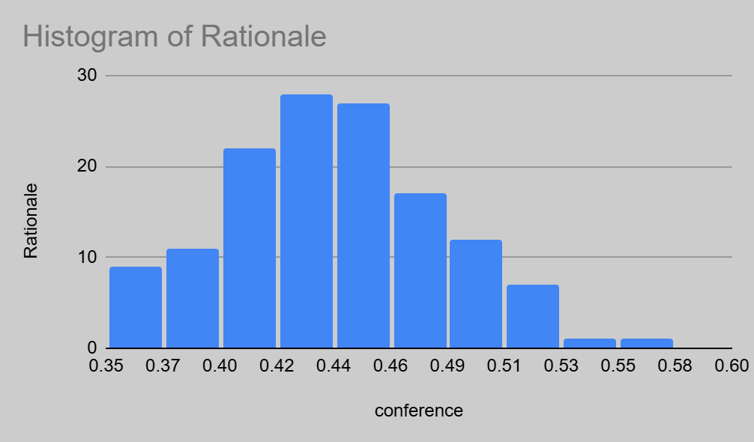

**Bar graph ( conference vs rational)**

**Conclusion**

The proposed frameworks address critical challenges in the research paper evaluation and submission process. By integrating Flutter for app development, the system ensures a user-friendly interface, making it accessible to a broader audience. Combined with Docker for seamless deployment and advanced NLP and machine learning techniques, the frameworks achieve high objectivity, efficiency, and accuracy. These systems are designed to adapt to diverse research domains, streamline workflows, and expand for larger datasets, contributing significantly to academic publishing.